Copy and paste any of the below QR codes that match the resource needed for your materials.

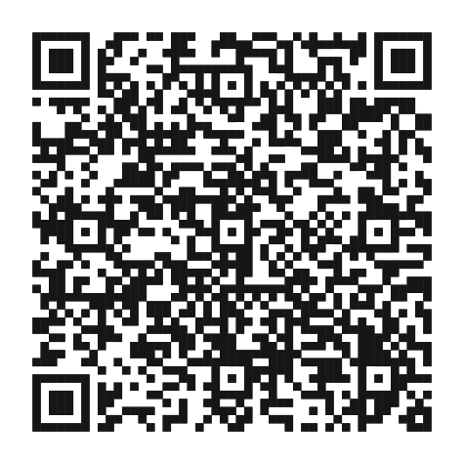
Premera.com (WA)
https://www.premera.com/?utm_source=blink&utm_medium=qr&utm_term=1&utm_campaign=employer-comm&utm_content=wa&lid=PBCWA:MKTG:MBR:blink:employer-comm:wa

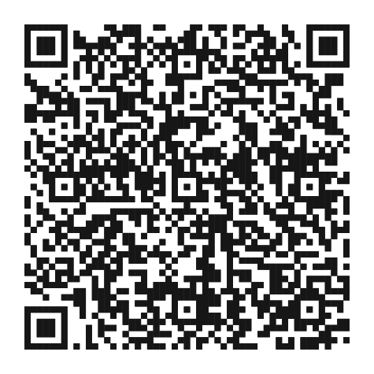
Premera App Store (WA)
https://blue.premera.com/premeraapp?utm_source=blink&utm_medium=qr&utm_term=1&utm_campaign=employer-comm&utm_content=wa&lid=PBCWA:MKTG:MBR:blink:employer-comm:wa

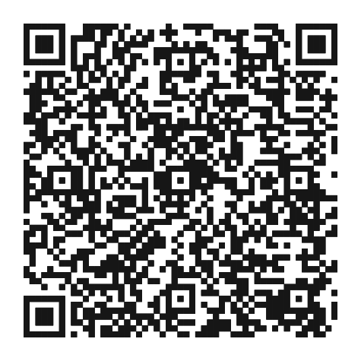
Premera MyCare App Store (WA)
https://blue.premera.com/mycareapp?utm_source=blink&utm_medium=qr&utm_term=1&utm_campaign=employer-comm&utm_content=wa&lid=PBCWA:MKTG:MBR:blink:employer-comm:wa

